## Lifecycle Hooks

**Learning Objectives**

* Understand the different phases an Angular component goes through from being created to being destroyed.
* Know how to hook into those phases and run your own code.
* Know the order in which the different phases happen and what triggers each phase.

**Phases**

A component in Angular has a life-cycle, a number of different phases it goes through from birth to death.

We can hook into those different phases to get some pretty fine grained control of our application.

To do this we add some specific methods to our component class which get called during each of these life-cycle phases, we call those methods *hooks*.

The hooks are executed in this order:

These phases are broadly split up into phases that are linked to the component itself and phases that are linked to the *children* of that component.

### Hooks for the component

**constructor**

This is invoked when Angular creates a component or directive by calling new on the class.

**ngOnChanges**

Invoked **every** time there is a change in one of th *input* properties of the component.

**ngOnInit**

Invoked when given component has been initialized.

This hook is only called **once** after the first ngOnChanges

**ngDoCheck**

Invoked when the change detector of the given component is invoked. It allows us to implement our own change detection algorithm for the given component.

ngDoCheck and ngOnChanges should not be implemented together on the same

component.

We will cover this hook in more detail in the *Advanced Components* section at the end of this course.

**ngOnDestroy**

This method will be invoked just before Angular destroys the component.

Use this hook to unsubscribe observables and detach event handlers to avoid memory leaks.

### Hooks for the components children

These hooks are only called for components and not directives.

 We will cover the difference between Components and Directives in the nextsection.

**ngAfterContentInit**

Invoked *after* Angular performs any content projection into the components view (see the previous lecture on *Content Projection* for more info).

**ngAfterContentChecked**

Invoked each time the content of the given component has been checked by the change detection mechanism of Angular.

**ngAfterViewInit**

Invoked when the component’s view has been fully initialized.

**ngAfterViewChecked**

Invoked each time the view of the given component has been checked by the change detection mechanism of Angular.

 We’ll dig into the children hooks in more detail in the next lecture.

**Adding hooks**

In order to demonstrate how the hooks work we’ll adjust the joke application we’ve been working with so far.

Firstly lets change the JokeComponent so it hooks into all the phases.

All we need to do is to add functions to the component class matching the hook names above, like so:

class JokeComponent {

@Input('joke') data: Joke;

constructor() {

console.log(`new - data is ${this.data}`);

}

ngOnChanges() {

console.log(`ngOnChanges - data is ${this.data}`);

}

ngOnInit() {

console.log(`ngOnInit - data is ${this.data}`);

}

ngDoCheck() {

console.log("ngDoCheck")

}

ngAfterContentInit() {

console.log("ngAfterContentInit");

}

ngAfterContentChecked() {

console.log("ngAfterContentChecked");

}

ngAfterViewInit() {

console.log("ngAfterViewInit");

}

ngAfterViewChecked() {

console.log("ngAfterViewChecked");

}

ngOnDestroy() {

console.log("ngOnDestroy");

}

}

To easily trigger these hooks lets change the rest of the application. We remove the form and change the parent JokeListComponent so it has two buttons. One that adds a joke triggering Angular to create a new JokeComponent instance. Another button to clear the list of jokes triggering Angular to delete the JokeComponents.

@Component({

selector: 'joke-list',

template: `

<

joke *ngFor="let j of jokes" [joke]="j"

>

<span class="setup">{{ j.setup }} ?</span>

<h1 class="punchline">{{ j.punchline }}</h1>

<

/joke

>

<

button type="button"

class="btn btn-success"

(click)="addJoke()">Add Joke

<

/button

>

<

button type="button"

class="btn btn-danger"

(click)="deleteJoke()">Clear Jokes

<

/button

>

`

})

class JokeListComponent {

jokes: Joke[] = [];

addJoke() {

this.jokes.unshift(new Joke("What did the cheese say when it looked in the

mirror", "Hello-me (Halloumi)"));

}

deleteJoke() {

this.jokes = []

}

}

When we run this application we now see two buttons:

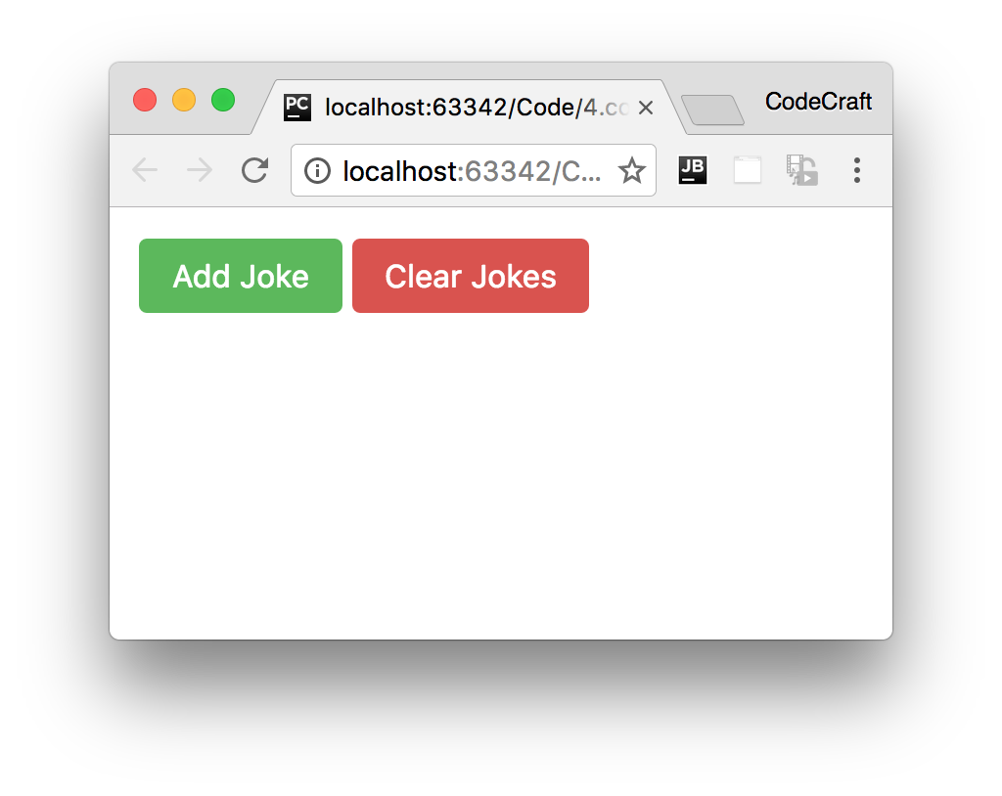

If we click "Add Joke" then a joke is added to the list and Angular creates an instance of the JokeComponent triggering the lifecycle hooks.

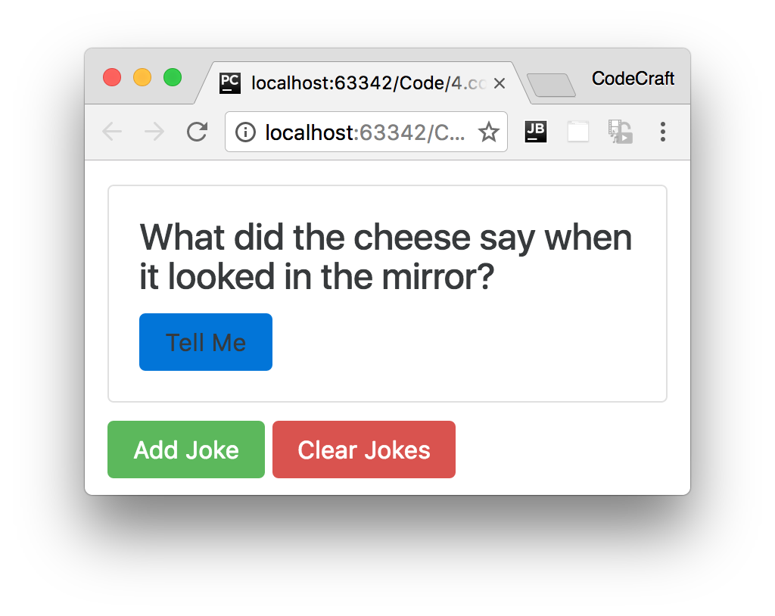

Looking at the console at this time we would see these logs:

new - data is undefined

ngOnChanges - data is [object Object]

ngOnInit - data is [object Object]

ngDoCheck

ngAfterContentInit

ngAfterContentChecked

ngAfterViewInit

ngAfterViewChecked

For the first 3 hooks we are also printing out the value of the components joke input property.

We can see that in the constructor the input property is undefined.

However by the time the ngOnChanges hook is called we can see that the input property is now set to the joke.

The best place to initialise your components is in the ngOnInit lifecycle hook and not the constructor because only at this point have any input property bindings

been processed.

The reason we use ngOnInit and not ngOnChanges to initialise a component is that ngOnInit is only called *once* whereas ngOnChanges is called for every change to the input properties.

When we press the *Clear Jokes* button, Angular deletes the JokeComponent and calls the ngOnDestroy hook which we can see in the logs like so:

ngOnDestroy

**Detecting what has changed**

We can actually tap into the exact changes to the input properties by examining the first param to the ngOnChanges function, which we typically call changes.

The type of changes is a map of the input property name to an instance of SimpleChange:

class SimpleChange {

constructor(previousValue: any, currentValue: any)

previousValue : any

currentValue : any

isFirstChange() : boolean

}

Using the above we can find out in our ngOnChanges function which input properties changed (if we have more than one) and also what the previous and current values are.

We change our ngOnChanges function to take the changes argument and loop through it to print out the SimpleChange.currentValue and previousValue.

ngOnChanges(changes: SimpleChanges) {

console.log(`ngOnChanges - data is ${this.data}`);

for (let key in changes) {

console.log(`${key} changed.

Current: ${changes[key].currentValue}.

Previous: ${changes[key].previousValue}`);

}

}

This prints out the below to the console:

ngOnChanges - data is [object Object]

data changed.

Current: [object Object].

Previous: CD_INIT_VALUE

The current value is the joke object that was bound to the data input property.

 When no value has been set for an input property it gets defaulted to the string'CD_INIT_VALUE' rather than null or undefined.

**Interfaces**

In the sample code so far we are just defining the hook functions directly on the class, but we can take advantage of a feature of TypeScript, interfaces, and be more explicit regarding our intentions.

Each of these lifecycle hooks has an associated typescript interface of the same name but without the ng prefix. So ngOnChanges has an interface called OnChanges.

Each interface defines just one hook, by making a class implement an interface we are saying we expect the class to have implemented that member function, if it doesn’t then TypeScript should throw an error.

Adding the interfaces for our life-cycle hooks to our JokeComponent class would look something like so:

import {

OnChanges,

OnInit,

DoCheck,

AfterContentInit,

AfterContentChecked,

AfterViewInit,

AfterViewChecked,

OnDestroy

}

from '@angular/core';

class JokeComponent implements

OnChanges,

OnInit,

DoCheck,

AfterContentInit,

AfterContentChecked,

AfterViewInit,

AfterViewChecked,

OnDestroy {

...

}



The browser based TypeScript compiler doesn’t trigger a compilation error when

we don’t implement interface functions so we actually can’t see the benefit of this

in the browser, but doing this using the offline local compiler will throw an error.

**Summary**

Using life-cycle hooks we can fine tune the behaviour of our components during creation, update and destruction.

We use the ngOnInit hook most often, this is where we place any initialisation logic for our component. It’s preferred over initialising via the constructor since in the constructor we don’t yet have access to the input properties whereas by the time ngOnInit is called they have been bound to and are available to use.

ngOnChanges is the second most common hook, this is where we can find out details about which input properties have changed and how they have changed.

The third most common hook is ngOnDestroy which is where we place any cleanup logic for our component.

**Listing**

<http://plnkr.co/edit/gIQCdWyb4sL4ZpDIyrFV?p=preview>

*script.ts*

import {platformBrowserDynamic} from '@angular/platform-browser-dynamic';

import {

Component,

NgModule,

Input,

Output,

EventEmitter,

ViewEncapsulation,

SimpleChanges,

OnChanges,

OnInit,

DoCheck,

AfterContentInit,

AfterContentChecked,

AfterViewInit,

AfterViewChecked,

OnDestroy

}

from '@angular/core';

import {BrowserModule} from '@angular/platform-browser';

class Joke {

public setup: string;

public punchline: string;

public hide: boolean;

constructor(setup: string, punchline: string) {

this.setup = setup;

this.punchline = punchline;

this.hide = true;

}

toggle() {

this.hide = !this.hide;

}

}

@Component({

selector: 'joke',

template: `

div class="card card-block"

>

<

<h4 class="card-title">

<ng-content select=".setup"></ng-content>

</h4>

<p class="card-text"

[hidden]="data.hide">

<ng-content select=".punchline"></ng-content>

</p>

<a class="btn btn-primary"

(click)="data.toggle()">Tell Me

</a>

<

/div

>

`

})

class JokeComponent implements OnChanges,

OnInit,

DoCheck,

AfterContentInit,

AfterContentChecked,

AfterViewInit,

AfterViewChecked,

OnDestroy {

@Input('joke') data: Joke;

constructor() {

console.log(`new - data is ${this.data}`);

}

ngOnChanges(changes: SimpleChanges) {

console.log(`ngOnChanges - data is ${this.data}`);

for (let key in changes) {

console.log(`${key} changed.

Current: ${changes[key].currentValue}.

Previous: ${changes[key].previousValue}`);

}

}

ngOnInit() {

console.log(`ngOnInit - data is ${this.data}`);

}

ngDoCheck() {

console.log("ngDoCheck")

}

ngAfterContentInit() {

console.log("ngAfterContentInit");

}

ngAfterContentChecked() {

console.log("ngAfterContentChecked");

}

ngAfterViewInit() {

console.log("ngAfterViewInit");

}

ngAfterViewChecked() {

console.log("ngAfterViewChecked");

}

ngOnDestroy() {

console.log("ngOnDestroy");

}

}

@Component({

selector: 'joke-list',

template: `

<

joke *ngFor="let j of jokes" [joke]="j"

>

<span class="setup">{{ j.setup }}?</span>

<h1 class="punchline">{{ j.punchline }}</h1>

<

/joke

>

<

button type="button"

class="btn btn-success"

(click)="addJoke()">Add Joke

<

/button

>

<button type="button"

class="btn btn-danger"

(click)="deleteJoke()">Clear Jokes

<

/button

>

`

})

class JokeListComponent {

jokes: Joke[] = [];

addJoke() {

this.jokes.unshift(new Joke("What did the cheese say when it looked in the

mirror", "Hello-me (Halloumi)"));

}

deleteJoke() {

this.jokes = []

}

}

@Component({

selector: 'app',

template: `

<

joke-list></joke-list

>

`

})

class AppComponent {

}

@NgModule({

imports: [BrowserModule],

declarations: [

AppComponent,

JokeComponent,

JokeListComponent

],

bootstrap: [AppComponent]

})

export class AppModule {

}

platformBrowserDynamic().bootstrapModule(AppModule);